Daniela Gonzalez

Linux Admin Set-up Doc
- sudo su – switches to a root user
- ip route – finds default gateway
- cat /etc/resolv.conf or nmcli dev show | grep DNS – determine DNS server
- $ - normal user
- # - root user
- tty = terminal / text input-output enviro
- creating an account:
  - #adduser [username]
  - #passwd [user password]
- who – view the users logged in to the terminal
- important terminal commands from lab:
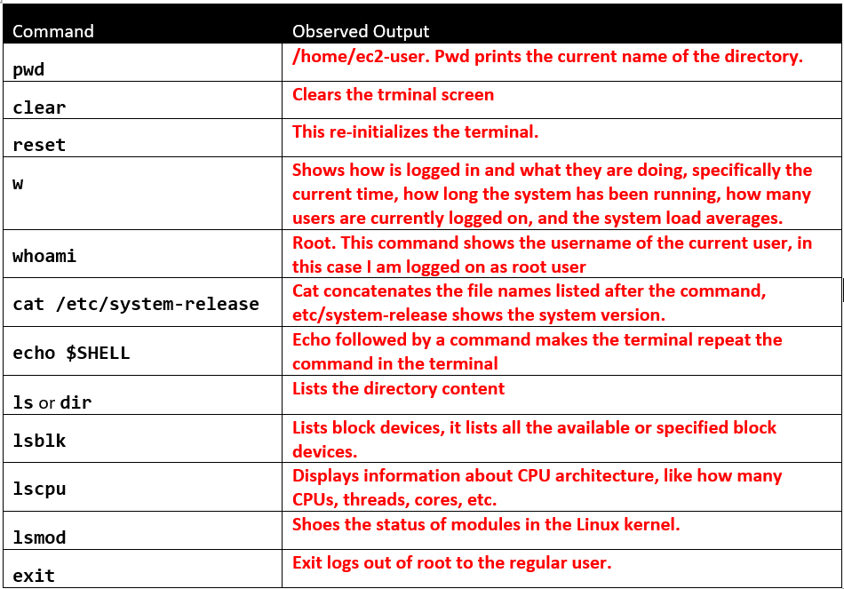
- some meta characters:
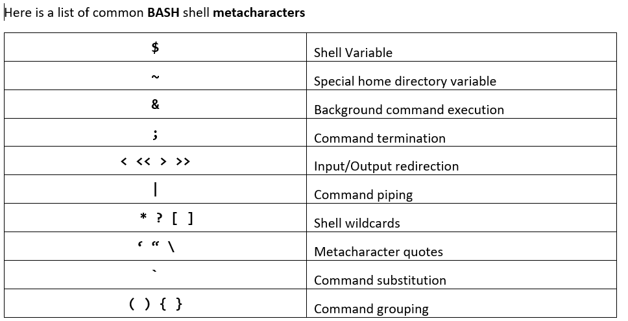
- crontab explained:
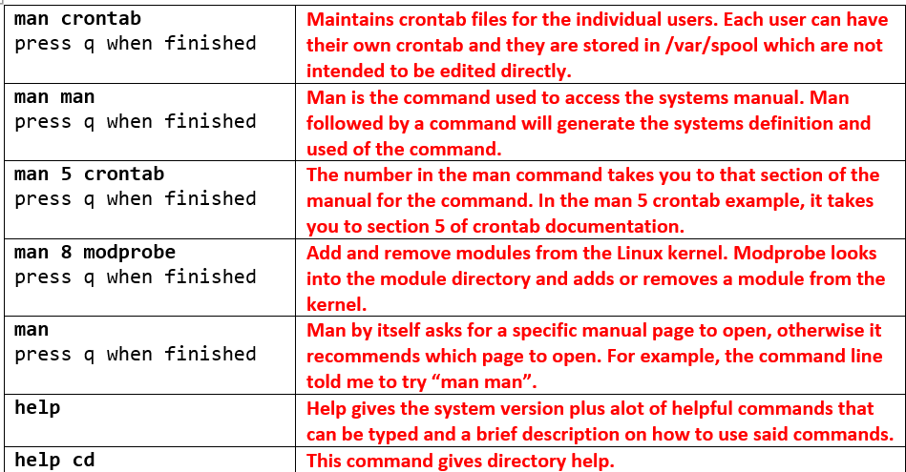
- Important terminal commands to know:
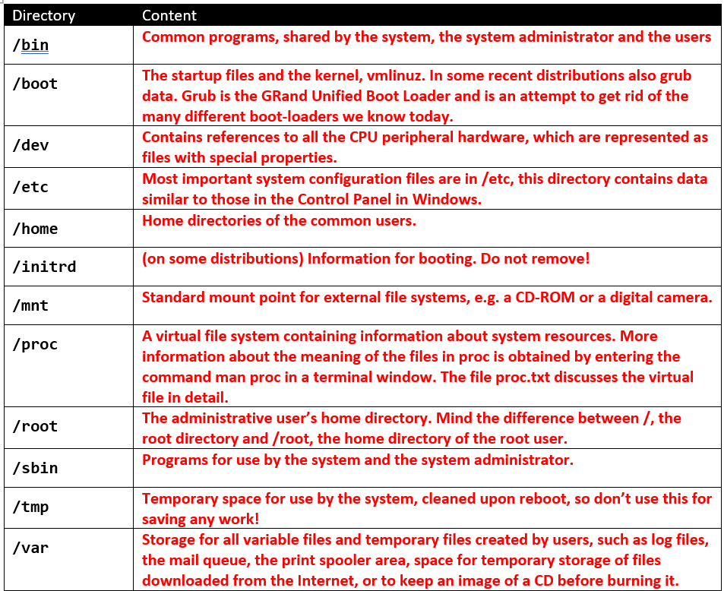
- When needed help with vim in terminal use VIMTUTOR!!!!!
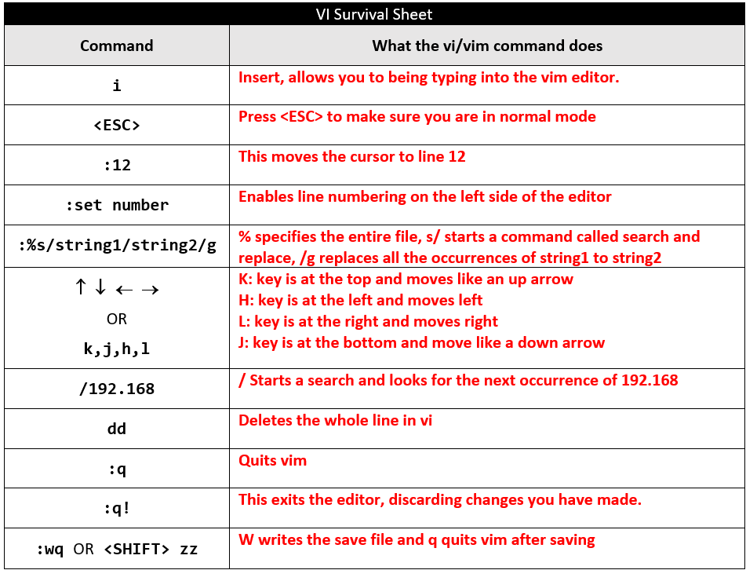
- Identifying Major and Minor device types, Commands via dev:
  - cd /dev
  - ll /dev/xv* lists available hard drives and existing partitions
- When you add new hard drives to partition them follow:
  - fdisk /dev/xvdb (xvdb is the new hard drive in this instance)
  - the next command prompts are answered as follows:
    - n
    - <ENTER>
    - <ENTER>
    - <ENTER>
    - <ENTER>
    - w
  - Use mke2fs to create an ext4 file system on the new partition:
    - mke2fs -t ext4 /dev/xvdb1
  - With the partition formatted, create a mountpoint: in the root directory and test it:
    - mkdir /hddmount
    - mount -t ext4 /dev/xvdb1 /hddmount
  - to check if its successful:
    - mount | grep sdb1
    - df -h
- Now proceed very carefully in the next steps!!! We will be editing the /etc/fstab with vim:
  - Use blkid to get the UUID’s
  - Umount /hddmount
  - Vim /etc/fstab
    - Will look something like this:
    - # /etc/fstab # Created by anaconda on Wed Jan 10 19:22:07 2024
#
# Accessible filesystems, by reference, are maintained under ‘/dev/disk/’.
# See man pages fstab(5), findfs(8), mount(8) and/or blkid(8) for more info. # # After editing this file, run ‘systemctl daemon-reload’ to update systemd. # units generated from this file.
#
UUID=c3527f51-3487-4a35-a5c2-2022396a34c3 / xfs defaults 0 0 UUID=b54999d4-4da2-418f-9e1a-2c3293616962 swap swap defaults 0 0 UUID=xxxxxxxx-xxxx-xxxx-xxxx-xxxxxxxxxxxx /hddmount ext4 defaults 0 0
:wq
  - Mount -a
  - mount | grep xvdb1 You should now see /dev/xvb1 mounted on /hddmount
  - If there is an issue this command might work to fix it mount –o nouuid /[device] /[mountpoint]
- Creating and Working with Logical Volumes
  - lsblk
  - dnf install -y lvm2
  - pvcreate /dev/xvdc1 /dev/xvdd1
  - vgcreate vg40 /dev/xvdc1 /dev/xvdd1 to create a volume group
  - lvcreate -L 30GiB -n volume30 vg40 to create a logical volume
- Commands to know and what they do:
  - # pvdisplay - From what I can see it displays the specifics of the 20G volumes we created and attached
  - # pvscan - This scans for the physical volumes in the system
  - # vgdisplay - This displays details of our volume groups
  - # vgscan - Scans for the vg group that we created previously
  - # lvdisplay - Displays various details of our logical volumes we created those being volume10 and volume30
  - # lvscan - Scans for the location of the logical volumes and their size
- Checking
  - Enter the df -h command to view the available space on your mounted filesystems.
  - Enter the df -ih command to view the available inodes on your mounted filesystems.
  - Enter the lsblk -f command to view block level summary information about filesystems.
- Quotas:
  - # dnf -y install quota
  - # quotacheck -mavugf -F vfsv0
    - quotacheck → This command checks and updates the disk quota usage on a file system.
-m → Remounts the filesystem in read-only mode to avoid corruption while scanning.
-a → Checks all mounted file systems that have quotas enabled.
-v → Enables verbose mode, displaying details of the quota check process.
-u → Checks user quotas.
-g → Checks group quotas.
-f → Forces a scan of the filesystem even if it's not marked dirty.
-F vfsv0 → Specifies the quota format to use (in this case, vfsv0, which is an older quota format used in some Linux distributions).F
  - # ll /volume10mount Verify the aquota.group and aquota.user files were create
  - # quotaon -avug
    - quotaon → Turns on disk quota enforcement.
-a → Enables quotas on all mounted filesystems that support quotas (from /etc/fstab).
-v → Enables verbose mode to display messages about what quotas are being turned on.
-u → Enables user quotas.
-g → Enables group quotas.
  - # edquota -u user
    - Add the soft and hard limits
  - # su user
  - # dd if=/dev/zero of=/volume10mount/userdir/test bs=1024 count=130000
    - dd → A low-level command used for copying and converting data.
if=/dev/zero → Specifies the input file (if = input file). In this case, /dev/zero generates an endless stream of zero bytes.
of=/volume10mount/userdir/test → Specifies the output file (of = output file). This file will be created at the specified location.
bs=1024 → Block size of 1024 bytes (1 KB per block).
count=130000 → Number of blocks to write (130,000 blocks × 1 KB = 130 MB total file size).
- Text editing in vi editior:
  - Modifications: “\”txtt\”,\”txt\”\”txt\””
- To view your current runlevel/target, you can enter the legacy runlevel command, or issue the system command systemctl get-default:
  - # runlevel
  - # systemctl get-default
- You can also view all currently loaded targets by executing the following command:
  - # systemctl list-units –-type target
- To set the default target (runlevel), you can use the systemctl set-default command. Here is an example (no need to run this)
  - # systemctl set-default multi-user.target
  - # reboot
- configuration pointing to the /etc/init.d directory.
Legacy “init” | Systemd
Symbolic links in /etc/rc.d point to shell scripts in /etc/init.d | Uses “unit types” stored in /usr/lib/systemd/system/, /run/systemd/system, and /etc/systemd/system
Each folder in /etc/rc.d has symlinks for runlevels 0-6 | Config files and symlinks in /usr/lib/systemd/system retain settings for each service controlled by system
To control the order of init scripts that are Started and Stopped (or “killed”), the symlink files are named with the letter “S” for start and “K” for kill (or stop), followed by a number to control the order that the symlinks are referenced. | To control the services that start and stop, systemd parses the “.wants” configuration file/folder for each daemon. Dependencies are controlled using a variety of system triggers instead of basic start/kill scripts.
service command used to start/stop/restart | systemctl start-stop-restart/try-start/reload/is-active
chkconfig command used to enable/disable by runlevel using on/off | systemctl enable/disable/status/list-dependencies

- Install and start the cups printer system:
  - # dnf -y install cups
  - # systemctl start cups
  - # systemctl status cups
- Occasionally a service will need to be reloaded without causing a disruption in service to users. Not all, but some services/daemons support the “reload” command to read in configuration changes without killing all active processes/requests:
  - # systemctl reload crond
- To view all loaded active and inactive services, and see a list of all service unit files:
  - # systemctl list-units –-type service
  - # systemctl list-units –-type service -all
  - # systemctl list-unit-files –-type service
- To check, in brief, on an individual service to see if it is enabled, and it its active:
  - # systemctl is-enabled cups
  - # systemctl is-active cups
- To view which services are ordered to start (as a dependency) after a specified service:
  - # systemctl list-dependencies --after gdm
- To view which services are ordered to start (as a dependency) before a specified service:
  - # systemctl list-dependencies --before gdm
- To enable and disable a service to start (or not start) automatically, use the enable/disable argument:
  - # systemctl disable cups
  - # systemctl is-enabled cups ←Should show disabled
  - # systemctl enable cups
  - # systemctl is-enabled cups ←Should show enabled
- Also, there is an older (but still useful) terminal-based graphical configuration tool called “ntsysv” for configuring “SystemV” based init services and “systemd services.” Execute the following command:
  - # ntsysv ← Use the TAB and arrow keys to navigate.
- Create your own Systemd Service:
  - Begin by creating the main script/service in the /usr/bin directory and type the following “code” to create the sample service:
    - # vim /usr/bin/sample.sh
#!/bin/bash
COUNTER=0
while [ $COUNTER -lt 1000 ]; do
date >> /tmp/sample.txt
sleep 3
let COUNTER=COUNTER+1
done
:wq
  - Next make the sample script executable:
    - # chmod 755 /usr/bin/sample.sh
  - Now create and edit a new .service file called sample.service in the /usr/lib/systemd/system directory
    - # vim /usr/lib/systemd/system/sample.service
[Unit]
Description = My Sample Service
After = network.target
[Service]
ExecStart = /usr/bin/sample.sh
[Install]
WantedBy = multi-user.target
  - The last step to creating the new service is to enable he service with the systemctl command:
    - # systemctl enable sample.service
  - Now start the service and verify it successfully started by checking the /tmp/sample.txt file:
    - # systemctl start sample.service
    - # tail -f /tmp/sample.txt Note: You can press <CTRL> + C to terminate the tail command.
- ps Commands:
  - # ps Shows just the processes for the current user
  - # ps -ef Shows all (-e) processes and displays in full-format listing (-f)
  - # ps -elf Shows all processes, full-format, in long format (-l)
- Schedule a couple of commands to run one minute in the future. Enter the following “at” command to open an interactive “at-shell” prompt, then enter the proceeding commands to finalize the schedule:
  - # dnf install at
  - # systemctl enable atd
  - # systemctl start atd
# at now +1 minute
at> date
at> who
<CTRL> + D
- When you press <CTRL> + D, the “at” command will process the commands you entered at the interactive prompt in one minute. The output from the commands will not display on the screen, they will be sent to the root email account. Check the results of root’s email account by entering the “mailx” command:
  - # dnf install /bin/mailx
  - # mailx
- Here is a list of the most common supported strings (macros):
String | Meaning
@reboot | Run once, at startup
@yearly | Run once a year, “0 0 1 1 *”
@monthly | Run once a month, “0 0 1 * *”
@weekly | Run once a week, “0 0 * * 0”
@daily | Run once a day, “0 0 * * *”
@hourly | Run once an hour, “0 * * * *”

- Before configuring crontab, verify the crond daemon is active (running):
  - # systemctl status crond
- Also, check to verify crond is enabled to run on boot:
  - # systemctl list-unit-files | grep crond
- Enter the crontab -l command to see if root currently has any cron table entries. (Note: there should not be any by default)
- Create a cron entry for root to run the sleep command on system startup:
  - # crontab -e ←the “-e” will open the vi editor to edit the cron entry
- # vim /etc/crontab
  - Note: Enter this line at the bottom of the file
* * * mar,jul mon,tue,wed,thu,fri root /bin/date >>/root/cron-date.txt
When finished editing, write and quit out of the /etc/crontab file.
- Wait patiently (about a minute) for the cron-date.txt file to appear in the /root directory. Use the cat (or tail) command to monitor the contents of the cron-date.txt file. You should see the date results appended to the file every minute.
  - # cat /root/cron-date.txt
OR
# tail -f /root/cron-date.txt

